Effect of preservation and life-stage on length-weight regressions for Mysis relicta

Jason D. Stockwell^{1,3}, Kate Janes², Derek H. Ogle², and Edmund J. Isaac¹
(Order of authors and additional co-authors can be decided upon as this evolves)
¹United States Geological Survey - Great Lakes Science Center
Lake Superior Biological Station
2800 Lakeshore Drive
Ashland, WI 54806
Phone: (715) 682-6163, FAX: (715) 682-6511

²Northland College
Department of Mathematics and Applied Statistics
1600 Ellis Avenue
Ashland, WI 54806
Phone: (715) 682-1300, FAX: (715) 682-xxxx

jstockwell@usgs.gov, janesk01@northland.edu, dogle@northland.edu

Running title: Length-weight regression for Mysis relicta

³Corresponding author
ABSTRACT. We did a kick ass job on this project. All objectives were met, and we had a lot of fun…

INDEX WORDS: Mysis relicta, length, weight, regression, Lake Superior, formalin.

INTRODUCTION
- Mysis relicta play an important role in Great Lakes food webs by linking pelagic and benthic food webs.
- With apparent decreases in Diporeia populations in many of the Great Lakes, many fish species may switch to M. relicta, the only other available large macroinvertebrate.
- To understand changes in the food web and how M. relicta may become a pivotal player, researchers will need good estimates of abundance and biomass.
- There have only been a few published length-weight relationships in the Great Lakes literature for M. relicta, and these have been determined using preserved specimens from Lake Ontario.
Objectives
- To test for any effect preservative may have on length measurements of M. relicta over two different time scales (≤ 2 weeks and ≈ 2 months).
- To develop a length-dry weight (L-W) regression for fresh (frozen) M. relicta in Lake Superior.
- To test the null hypothesis that L-W regressions for different life-stages are not significantly different from each other.
- To test the null hypothesis that the L-W regression for fresh (frozen) M. relicta is not significantly different from L-W regressions derived from M. relicta preserved in 8% sugared-buffered formalin over two different time scales (≤ 2 weeks and ≈ 2 months).
METHODS
Field Collections and Length Measurements
As part of the ongoing Lower Food Web study, M. relicta will be sampled at stations 139, 172, and LIMN_201 with a 1-m² Mysis net in early May. Samples will be collected from 2 m above the bottom to surface, with a 30 second delay between when the net reaches the bottom and when it is retrieved (to allow re-distribution of M. relicta). The net will be retrieved at 0.3 m/sec. Sampling will be done at night with no white lights visible on the ship because M. relicta is very sensitive to white light. Red lights will be used on the ship 15 minutes prior to and during sampling. Quadruplicate tows will be made at each station and will be preserved in 8% sugared-buffered formalin. An additional tow will be made at each station to collect individuals for developing the L-W regression for fresh (frozen) M. relicta.
Upon completion of the five replicate tows at each station, the sample for the fresh L-W regression will be processed immediately. Soda water will be added to the sample to anaesthetize the animals. Mysids will be sexed if they are ≥ 9 mm, grouped in three’s and photographed with a digital camera with a ruler as a backdrop. Individuals in each photograph will be uniquely identified by position in photograph (e.g., 1 = top individual, 2 = middle, and 3 = bottom) and photograph file name/number. We will target 12 individuals per 2-mm length bin (starting at 3 mm) for each of 4 life-stages (immatures < 9 mm, males, non-gravid females, and gravid females) for statistical analyses. We will also test for the effects of preservation on length measurements, targeting an additional 6 individuals per length bin/life-stage.
After photographing, the first 2 individuals per length bin/life-stage will be frozen individually in bullet tubes with a small amount of water sufficient to cover the specimen and the next individual will be preserved in 8% sugared-buffered formalin in an individual bullet tube. Note: A rack to hold individual bullet tubes upright with preserved Mysids would be useful to avoid possible linkage of preservative. This pattern will be repeated until a total of 12 individuals have been frozen and 6 individuals preserved for each length bin/life-stage. Because gravid females will likely be rare, 12 individual gravid females per length bin for L-W analyses should be collected first, and then 6 individuals for testing the effects of preservation on length should be collected if sufficient numbers are available. All bullet tubes will be labeled sequentially starting with “1” and cross-referenced with a master data sheet. The master data sheet will contain the following information: bullet tube label (1, 2, 3,…), photograph file name/number and individual number within photograph (to identify individual in photograph), date, time, station, life-stage (I = immature, M = male, F = non-gravid female, G = gravid female), preservation treatment (fresh, formalin [2 weeks], formalin [2 months]), purpose (L-W = regression, L = effects of preservation on length measurement), length (to nearest 0.1 mm; to be filled in after digital measuring), and dry weight (to nearest 0.01 mg). The master data sheet should also have a header with project identification, gear used to collect samples, and any other pertinent metadata. During field processing, tallies for length groups (by eye using ruler) should be kept to avoid collecting too many individuals of a particular length and thus wasting effort/resources. We are likely to see different length distributions between shallow (stations 139 and 172) and deep (station LIMN_201) stations based on last year’s sampling. Whichever length bin/life-stages are not filled up at the first station can be filled up at remaining stations. We are assuming no station effect in our analyses.
Standard length (rostrum to cleft in telson, to nearest 0.1 mm) of individual Mysids will be recorded from digital photographs using an image analysis system. This can be done on the ship or back at the laboratory.
Within two weeks after collection, the same process will be performed for one of the four preserved replicates from each station that was collected as part of the Lower Food Web study. After length measurements have been recorded, individuals will be placed in their own bullet tube with sufficient preservative. Note: these preserved samples will need to be processed in their entirety for lengths, sex/maturity, and counts as part of the Lower Food Web study. Also, the six individuals per length bin/life-stage that were measured fresh and then individually preserved in formalin will be measured for length to examine the effect of preservative (at this time scale) on length measurements. After measurement these individuals will be placed back into their respective bullet tubes for measurement at the 2-month mark.
For the two-month preservative treatment, the same procedures will be used on a second replicate tow that was preserved from each station for the Lower Food Web study. Note: these preserved samples will need to be processed in their entirety for lengths, sex/maturity, and counts as part of the Lower Food Web study. Length measurements will be made in early July 2006. The six individuals per length bin/life-stage that were measured fresh and after 2-weeks preservation in formalin will be measured for length again to examine the effect of preservative on length measurements after 2 months. They will be placed back into their respective bullet tubes in case “Contingency” plan below is put into action.
Dry Weight Measurements
Two weeks after processing fresh specimens for length, individual Mysids for dry weight determination (fresh and 2 week formalin preserved) will be transported to Dr. Mary Balcer’s laboratory at the University of Wisconsin – Superior. In Dr. Balcer’s laboratory, each individual will be placed in a pre-weighed aluminum dish and placed in a drying oven for 24 hours at 60˚C. After drying, individuals (plus dish) will be placed in a dessicator and allowed to cool for at least 1 hour. Individuals will then be weighed to the nearest 0.01 mg using an electronic microbalance. The microbalance resolution should be sufficient to resolve individual dry weight for the smallest individuals (see Fig. 2 in Shea and Makarewicz 1989).
For the two-month preservative treatment, the same procedures will be used on a second replicate tow that was preserved from each station. Dry weight measurements will be recorded in early July 2006.
Statistical Analysis
To test for the effect of preservative on length measurements, we will perform an ANCOVA with fresh length as the covariate, preservation time as the treatment, and the difference between fresh and preserved length of individuals as the observations. The null hypothesis is that slopes and intercepts are not different from zero, and there are no differences across preservation treatment times. Dr. Derek Ogle has some slight modifications to this method and will be consulted during analyses. If there are significant differences, then preserved lengths for the L-W analyses will be corrected accordingly to remove potential confounding effects of changes in length on the L-W relationship.
The effects of preservation treatment and life-stage on length-weight relationships were tested with linear models using weight as the response variable, length as a covariate, preservation treatment and life stage factors, and all corresponding two- and three-way interactions. Two separate linear models were initially fit because no gravid females were preserved in 8% buffered formalin. The first model examined the effect of all three preservation treatments and two life stages (males and females) on the length-weight relationship. The second model examined the effect of two preservation treatments (fresh preserved and 8% sugar-buffered formalin) on all three life stages. For each model, measured length and weight values were transformed to the log₁₀ scale to linearize the relationship, stabilize variances, and allow comparison with literature values. Main and interaction effects were tested with a Type II ANOVA (Fox 1997). In all models, three-way interaction and two-way factor interactions were insignificant indicating that there was no interaction between the preservation treatment and life stage factors in the slopes and intercepts of the length-weight relationships. Significant log₁₀(length) interaction terms (i.e., indicating different slopes) were further examined with reduced models and a false discovery rate of 0.05 (Benjamini and Hochberg 1995; Benjamini and Yekutieli 2001; Storey 2002; Verhoeven et al. 2005). Significant preservation treatment and life stage factor effects in the absence of length interaction terms (i.e., parallel lines) were further examined with Tukey’s HSD method on log₁₀(length)-adjusted mean log₁₀(weight). Final length-weight models for all significant different preservation treatment and life stage groups were determined by fitting appropriately reduced models.

Contingency
If a significant preservation effect is observed and response variable shows consistent and continual change out to two months, then another level to the preservation treatment can be added (e.g., 4 or 6 months) using remaining preserved samples to identify when the temporal effect of preservation levels off.

RESULTS
Length Analysis

Length-Weight Relationships
A total of 316 Mysids were measured and weighed for analysis of length-weight relaiontships. Characteristics of the sample separated by preservation treatment and life-stage are shown in Table 1.
The first linear model fit to males and females and all three preservation treatments showed that there was a significant difference in slope among the three preservation treatments (p=0.0222) but not among the two life-stages (p=0.4539). Post hoc multiple comparisons indicated that the 8% buffered formalin and 8% sugar-buffered formalin treatments had statistically similar slopes (q=0.8000) that were significantly steeper than the slope of the fresh preserved treatment (q<0.0815). Further comparisons indicated that the 8% sugar-buffered formalin treatment had a larger mean log(weight) than the 8% buffered formalin treatment for all values of log(length) (p<0.0005). The mean log(weight) adjusted for log(length) did not differ among the two life-stages (p=0.4338).
The second linear model fit to all three life-stages and the fresh preserved and 8% sugar-buffered formalin treatments showed that there was a significantly steeper slope for the 8% sugar-buffered formalin treatment (p=0.0127) but no difference in slope among the three life-stages (p=0.4201). Within a preservation treatment there was a significant difference in mean log(weight) adjusted for log(length) (p=0.0127) with gravid females being significantly heavier than male or non-gravid females (p<0.0333).
The results from the two linear model fits indicate that the length-weight relationships are unique to five different preservation treatment and life stage combinations (Figure 1). The specific relationships for these combinations are shown below.

Fresh preserved, Males & Females log₁₀(weight)= 2.7676*log₁₀(length)-2.4324
Fresh preserved, Gravid Females log₁₀(weight)= 2.7676*log₁₀(length)-2.3743
8% Buffered, Males & Females log₁₀(weight)= 3.0664*log₁₀(length)-2.7184
8% Sugar-buffered, Males & Females log₁₀(weight)= 3.0664*log₁₀(length)-2.5586
8% Sugar-buffered, Gravid Females log₁₀(weight)= 3.0664*log₁₀(length)-2.5824

DISCUSSION
Deliverables/Conclusions
This project will produce 1) recommendations for how to handle M. relicta to develop L-W regressions, 2) L-W regression(s) pooled appropriately between/among life-stages for Lake Superior, and 3) comparisons with L-W regressions from other Great Lakes.

ACKNOWLEDGMENTS
We thank Captain Joe Walters, First Mate Mike McCann, and Engineer Keith Peterson of the R/V Kiyi for their tireless work during field collections. Plus others…

REFERENCES
Benjamini, Y. and Y. Hochberg. 1995. Controlling the false discovery rate: a practical and powerful approach to multiple testing. Journal of the Royal Statistical Society, Series B, 57:289–300.
Benjamini, Y. and D. Yekutieli. 2001. The control of the false discovery rate in multiple testing under dependency. Annals of Statistics, 29:1165–1188.
Fox. J. 1997. Applied Regression Analysis, Linear Models, and Related Methods. Sage.
Shea, M.A., and J.C. Makarawicz. 1989. Production, biomass, and trophic interactions of Mysis relicta in Lake Ontario. J. Great Lakes Res. 15:223-232.
Storey, J.D. 2002. A direct approach to false discovery rates. Journal of the Royal Statistal Society, Series B, 64:479–498
Verhoeven, K.J.F., K.L. Simonsen, and L.M. McIntyre. 2005. Implementing false discovery rate control: increasing your power. Oikos, 108:643–647.
Table 1. Characteristics of the sample of Mysis used to determine length-weight relationships.
 |  |  |  |  | Standard Length (mm) |  |  |  |  | Dry Weight (μg)
Preservation | Stage |  | n |  | Min | Max | Mean | SD |  | Min | Max | Mean | SD
Fresh | Male |  | 54 |  | 8.1 | 15.8 | 12.9 | 1.89 |  | 1.2 | 10.0 | 4.6 | 2.10
Fresh | Female |  | 61 |  | 8.6 | 18.3 | 13.4 | 2.61 |  | 0.9 | 12.7 | 5.5 | 2.78
Fresh | Gravid |  | 22 |  | 12.9 | 18.2 | 15.2 | 1.51 |  | 4.0 | 14.7 | 8.1 | 2.51
8% Buffered | Male |  | 18 |  | 10.4 | 14.6 | 13.0 | 1.26 |  | 2.8 | 7.5 | 5.0 | 1.41
8% Buffered | Female |  | 24 |  | 8.9 | 16.0 | 12.0 | 2.52 |  | 1.3 | 11.5 | 4.6 | 3.25
8% Sugar-buffered | Male |  | 50 |  | 9.1 | 15.1 | 13.2 | 1.47 |  | 1.9 | 11.3 | 7.5 | 2.35
8% Sugar-buffered | Female |  | 60 |  | 8.2 | 18.0 | 13.2 | 2.54 |  | 1.7 | 19.0 | 7.9 | 4.14
8% Sugar-buffered | Gravid |  | 27 |  | 13.7 | 17.9 | 15.3 | 1.13 |  | 8.0 | 17.4 | 12.1 | 2.95

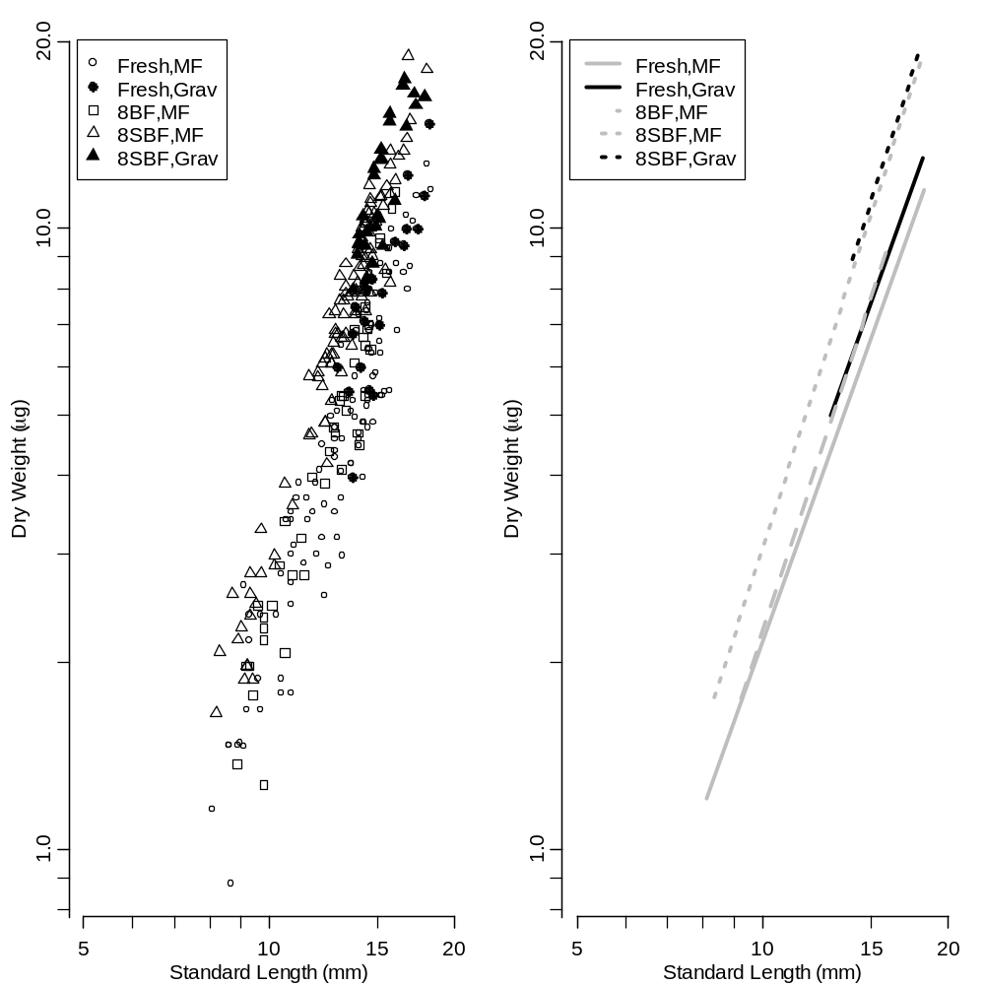
Figure 1. Plot of dry weight versus standard length (left) for five groups of Mysis with unique length-weigh relationships (right).

